CAR

RENTAL   
 SYSTEM

(ADVANCE WEB PROGRAMMING)

*~ Suresh Sir*

***Project By:***

***22742 Kavita Kotia***

***22743 Rohan Mistry***

***22744 Malaika Raut***

|  |  |  |
| --- | --- | --- |
| *Sr No.* | *Title* | *Page No.* |
| **1.** | ***Introduction*** | ***03*** |
| **2.** | ***Motivation*** | ***04*** |
| **3.** | ***Literature Survey*** | ***05*** |
| **4.** | ***Problems*** | ***06*** |
| **5.** | ***Methodology*** | ***07*** |
| ***6.*** | ***Results*** | ***09*** |
| ***7.*** | ***Future Scope*** | ***11*** |
| ***8.*** | ***Conclusion and References*** | ***12*** |

***INDEX***

*INTRODUCTION*

The Online Car Rental System is easy to use, full-featured and flexible car booking, car listing and car rental web portal. It allows Administrators of this car rental website you can add new or change locations, vehicle pictures, rate card. The e-CarRental System provides complete functionality of listing and booking car.

*MOTIVATION*

Nowadays, there is Online Car Rental, which benefits users greatly. A rental service is one where customers come to seek the rental of a rental unit. It is more convenient than paying for the unit's ownership and maintenance. A car rental company lends autos for a price for a few hours, a few days, or a week or more.

*LITERATURE SURVEY*

System analysis is a thorough examination of a system's different processes and their interrelationships both within and outside the system. The key question here is – why are there so many flaws in the current system? What measures should be taken to address the problem? When a user or management begins a study of the software utilising the current system, analysis begins. Data was collected on numerous files, decision points, and transactions handled by the current system during the analysis. For example, Data Flow Diagrams, etc. are widely utilised in the system. For the collection of important information needed to create the system, training, experience, and common sense are necessary. The system's success is primarily determined by how well the problem is identified, fully studied, and appropriately implemented via the selection of a solution. A good analytical model should include not just methods for comprehending the problem, but also the framework for solving it. As a result, it should be extensively investigated by gathering data about the system.

*PROBLEMS*

Car Rental System service will help users to book a car for some fee specified. Till now there was no clear web-based UI to help the users to rent the vehicle. They had to manually rent the vehicle through their offices. It was a difficult task to manage rental vehicles. Keeping track of all the rental cars was a problem. A car rental is a vehicle that may be rented for a price and utilised for a specific length of time. Getting a rental automobile makes it easier for people to travel around when they don't have access to their own vehicle or don't own one at all. A person who needs transportation must call a rental car company and sign a contract. This method improves client retention while also making car and employee management more straightforward.

*METHODOLOGY*

*Data Flow Diagram:*

The Data Flow Diagram shown below illustrates the general structure of the system. It demonstrates how and what sorts of services the customer chooses, as well as the amount of admin engagement.

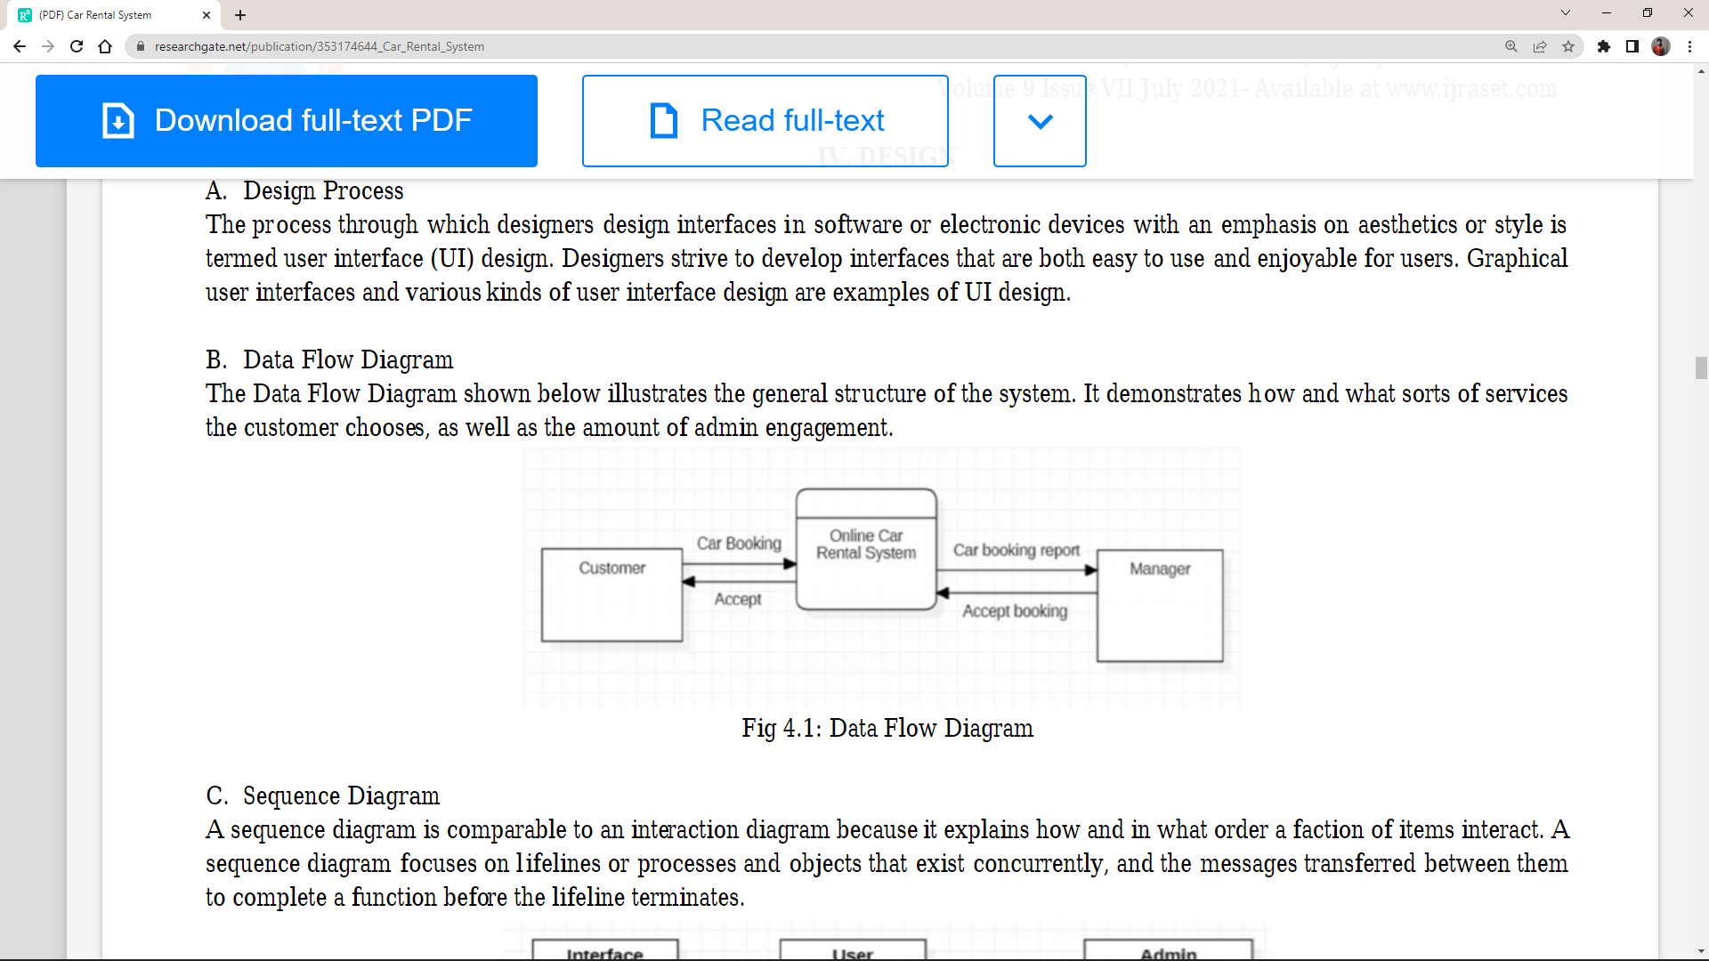

*ER/EER Diagram:*

The ER diagram depicts all of the relationships between entity sets in the database. It demonstrates the database's logical structure.

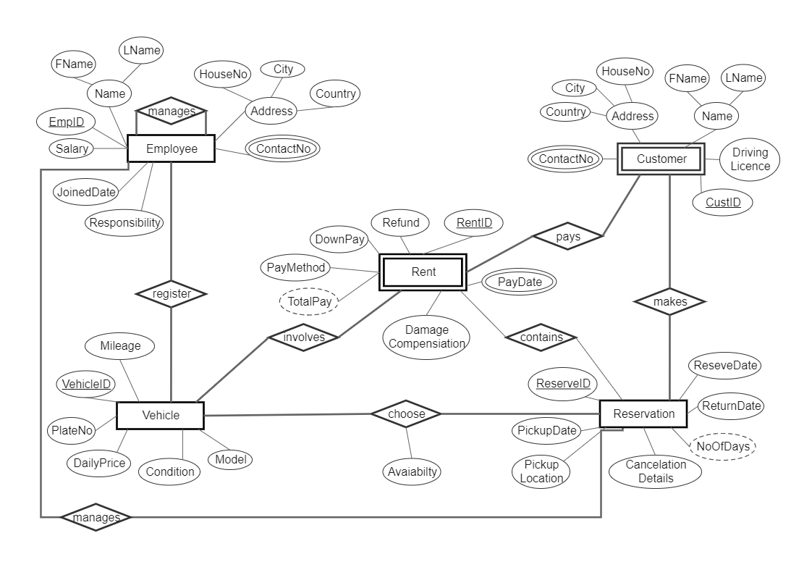

*RESULTS*

*This Car Rental System project will enable the user to rent a vehicle. The user shall login to the system and check for availability of cars.*

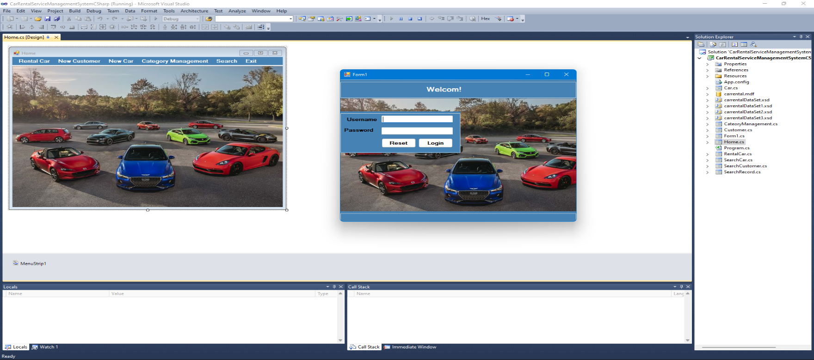

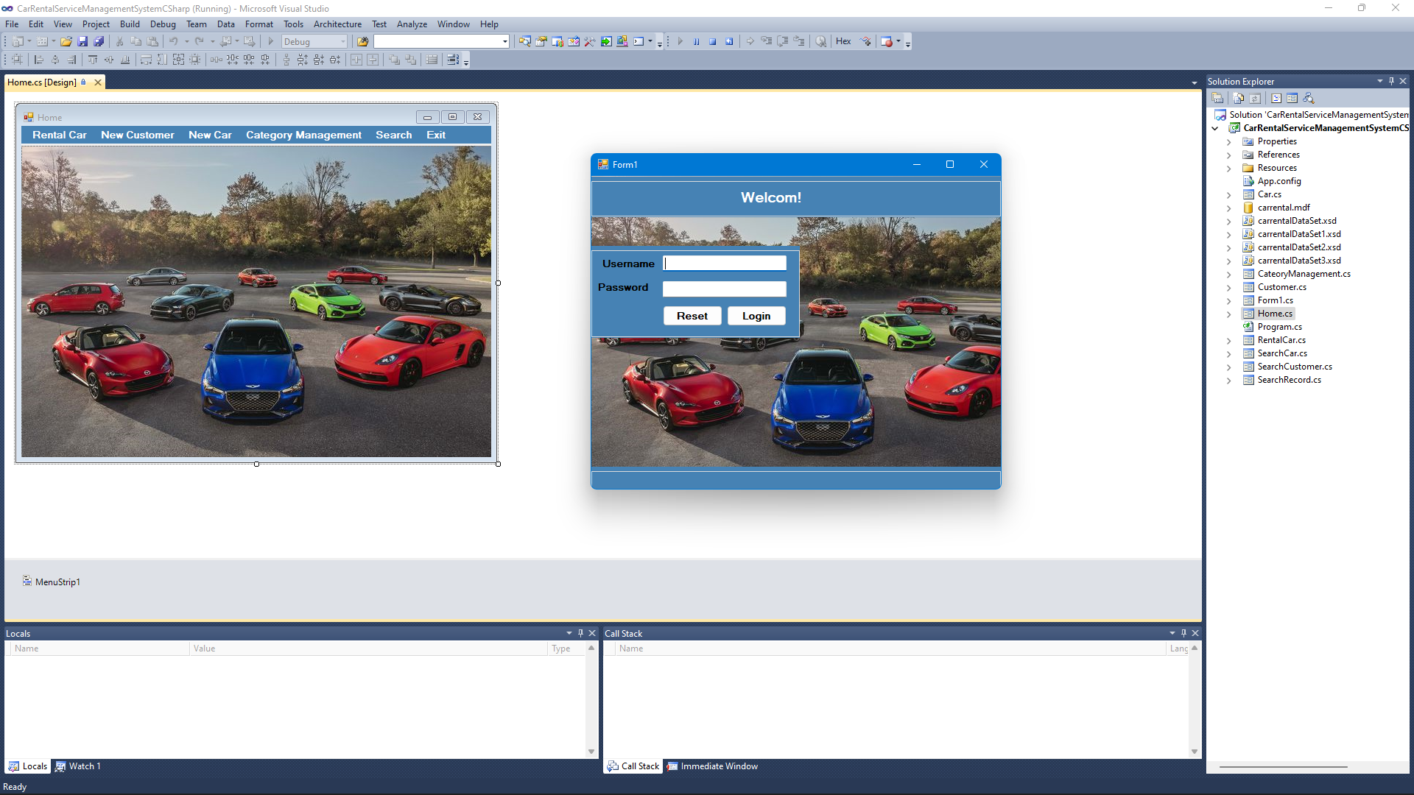

*All the data regarding the rental cars are stored in MySQL database. The user has to enter his name, address, phone details and check for the cars available for rent.*

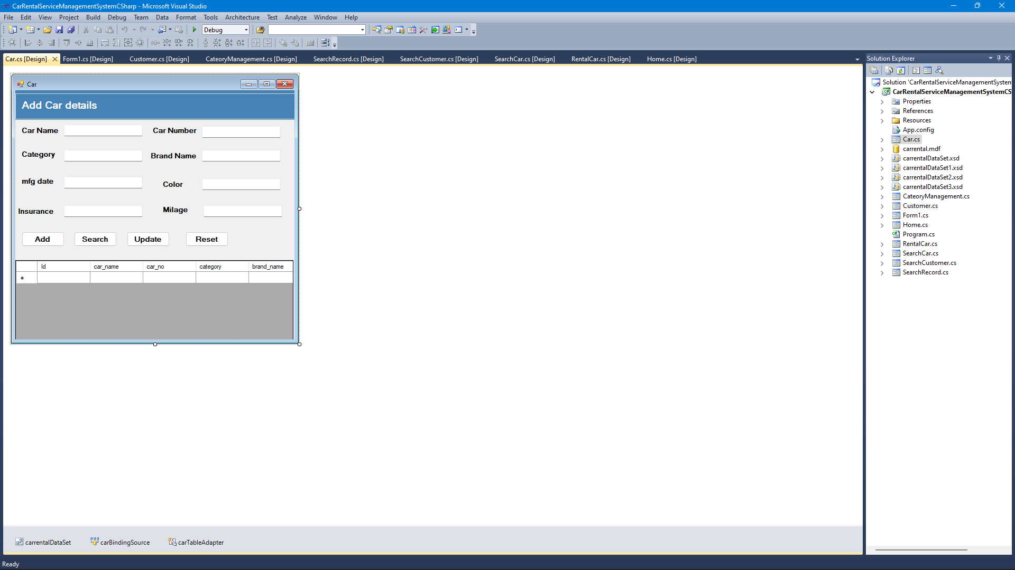

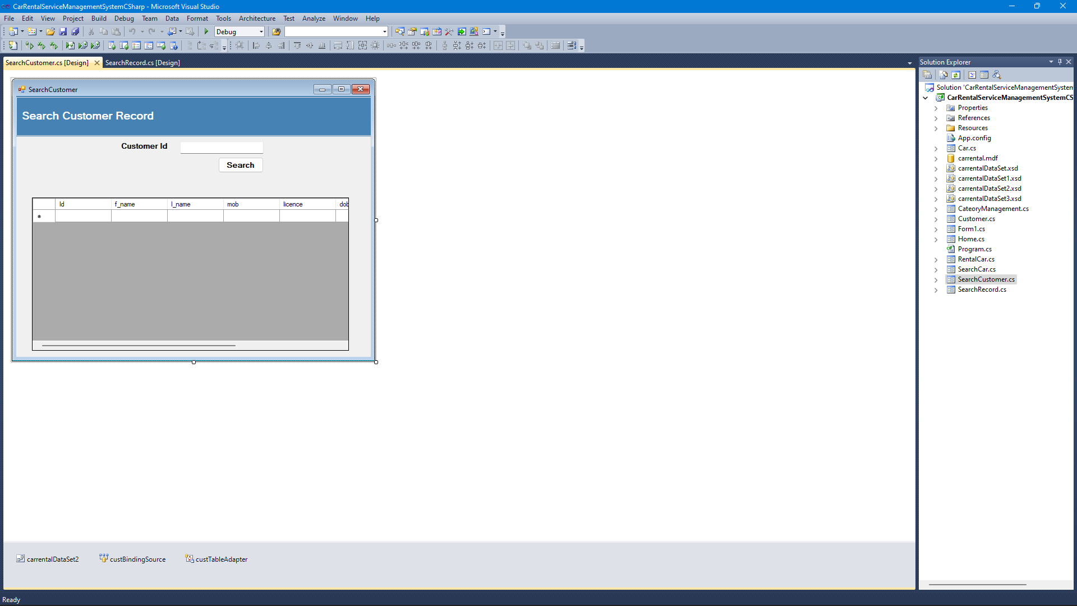

*FUTURE SCOPE*

*In a nutshell, it can be summarized that the future scope of the project circles around maintaining information regarding:*

* *We can add printer in future.*
* *We can give more advance software for Car Rental System including more facilities.*
* *We will host the platform on online servers to make it accessible worldwide.*
* *Integrate multiple load balancers to distribute the loads of the system.*
* *Create the master and slave database structure to reduce the overload of the database queries.*
* *Implement the backup mechanism for taking backup of codebase and database on regular basis on different servers.*

*CONCLUSION AND REFERENCES*

*The objective of this software is to provide a frame work that enables the manger to make reasonable estimates made within a limited time frame at the beginning of the software project and should be updated regularity as the project progresses.*

*At the end it is concluded that we have made efforts on following points:*

* *A description of the background and context of the project and its relation to work already done in the area.*
* *Made statement of the aims and objectives of the project.*
* *The description of Purpose, Scope, and applicability.*

[*https://www.academia.edu*](https://www.academia.edu/)

[*www.flightslogic.com*](http://www.flightslogic.com/)

[*https://www.altexsoft.com/blog/car-rental-reservation-system*](https://www.altexsoft.com/blog/car-rental-reservation-system)

[*https://www.researchgate.net/publication*](https://www.researchgate.net/publication)